

**NCEdCloud: Claiming Your Student Account**

**In order to claim your student account you will need your**

**Student User ID Number, birthdate, and current grade level.**

1. Using Google Chrome or Mozilla Firefox, visit <http://my.ncedcloud.org>
2. Click Claim My Account.

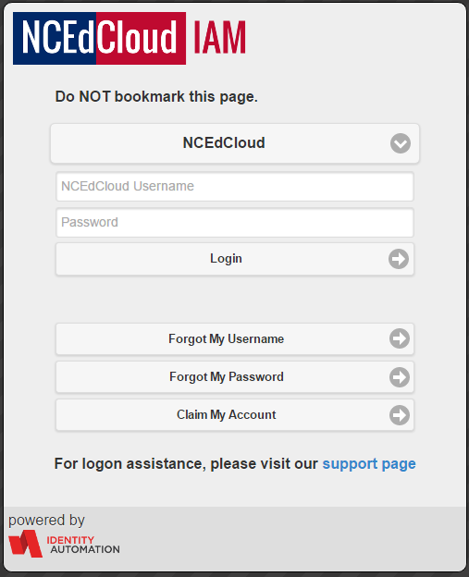

1. Select LEA Student Claim Policy.

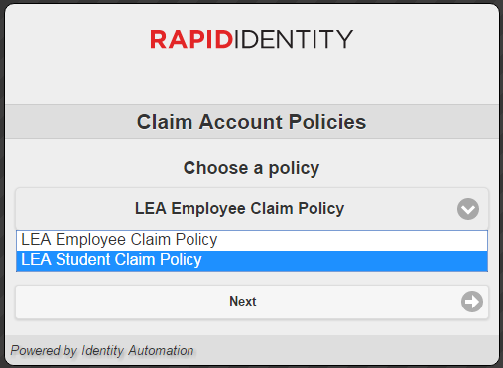

1. Click Next.

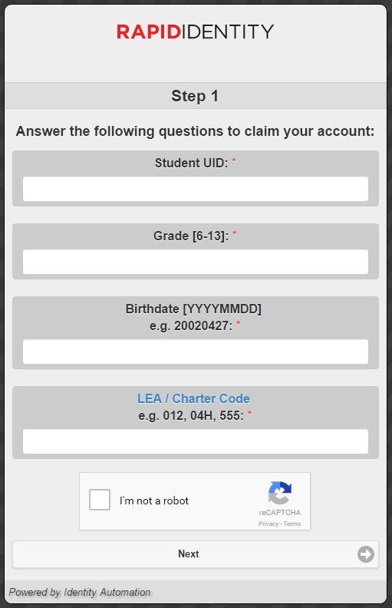

1. Enter the required Information

* Student UID
* Current grade level
* Birthdate – following the required

format: **YYYYMMDD**

* LEA: **320**
* Check the box “I’m not a robot”

1. 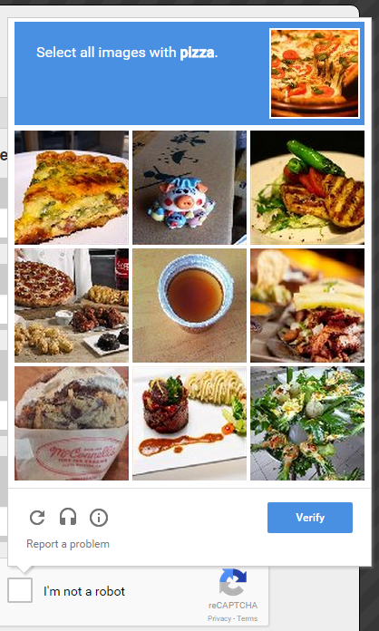If prompted, follow the instructions

on the next page (e.g. Select all

images with salad) and click Verify.

1. Click Next.
2. Create your new password (follow all requirements and write it down!)

You must type it twice (once on each line) to ensure your passwords match.

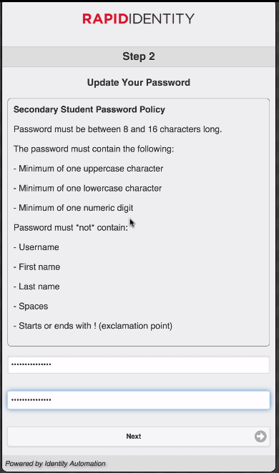

Password must

* Be between 8 and 16 characters long
* Contain at least one uppercase character
* Contain at least one lowercase character
* Contain at least one numberic digit

1. Click Next.
2. Answer at least 5 of the security questions. These questions will be used in the event you forget your password, so write down your answers.

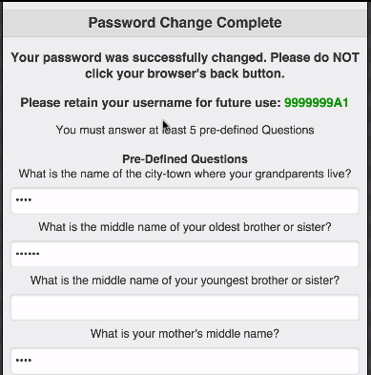

1. 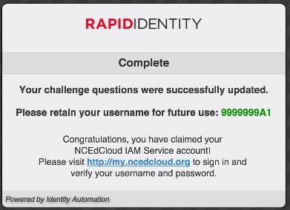 Click Next.

* A confirmation page is displayed.

1. Print this page and save it in a secure location.

You can now login to PowerSchool at <http://my.ncedcloud.org>

If additional assistance is needed, please let your teacher know.