Circulatory system Name:
Functions of the circulatory system
- Carries ______________ and ____________ ,and other materials to cells
- Carries _____________ _____________ and _____________ away from cells
- ________________________________________________________ and heals wounds
- ______________________________________________________________________________________________________________________________________________________________________________________
The circulatory system is made up of
- __________________________-

- __________________________-

Blood has 4 components:

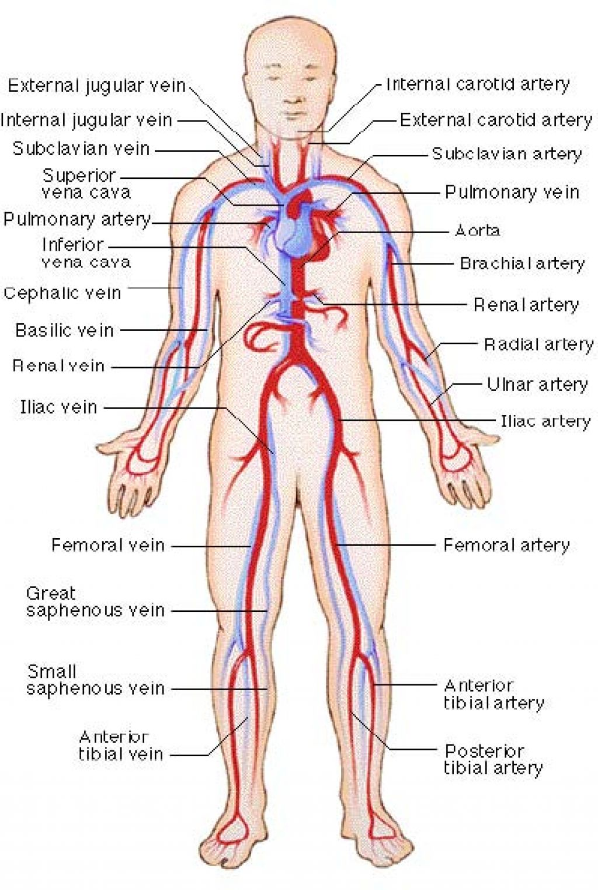

- _________________ __________________-

Arteries:

Capillaries:

Veins:

Blood Types:

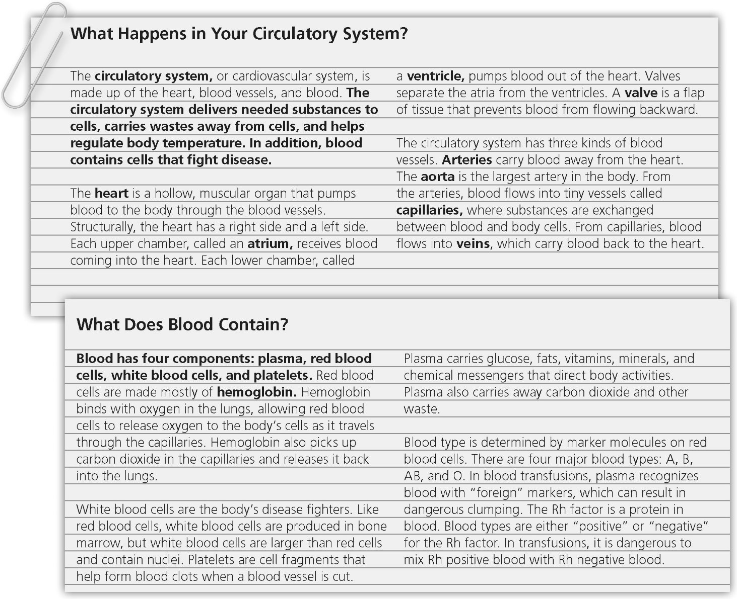

5. ___ circulatory system  6. ___ heart  7. ___ atrium  8. ___ ventricle  9. ___ hemoglobin  10. ___ valve  11. ___ arteries  12. ___ aorta  13. ___ capillaries  14. ___ veins | a. a protein that contains iron and binds chemically to oxygen  molecules in the lungs  b. a lower chamber of the heart  c. the body’s largest artery  d. the heart, blood vessels, and blood  e. blood vessels that carry blood back to the heart  f. an upper chamber of the heart  g. tiny blood vessels where substances are exchanged  between the blood and body cells  h. a flap of tissue that prevents blood from flowing backward  i. a hollow, muscular organ that pumps blood throughout  the body  j. blood vessels that carry blood away from the heart

